A Project Report shop

Elemental Fixers

Name: Arman madar mulani

Tecnology: HTML5,CSS3,Bootstrap5 & javascript

Date of submission: 30-05-2024

1. Overview:

At Elemental Fixers, we believe that every home deserves to be a haven. Our dedicated team of skilled professionals is here to tackleyourrepaiand maintenance needs, from plumbing and electrical work to carpentry and landscaping. With a commitment to quality and customer satisfaction, we ensure that every project is completed with precision and care.

Whether you need a quick fix or a complete renovation, Elemental Fixers is equipped to handle it all. We pride ourselves on our transparent pricing, timely service, and expert advice to help you make informed decisions for your home.

2.Objectives:

1. **Provide Comprehensive Home Repair Services**  
   Offer a wide range of repair and maintenance services to address all aspects of home care, ensuring that customers have a one-stop solution.
2. **Ensure Customer Satisfaction**  
   Prioritize customer feedback and satisfaction by delivering high-quality work and exceptional service, fostering long-term relationships.
3. **Promote Transparency and Trust**  
   Establish clear communication and transparent pricing to build trust with customers, making the repair process straightforward and stress-free.
4. **Educate Homeowners**  
   Provide valuable resources and tips on home maintenance, empowering customers to make informed decisions about their properties.
5. **Emphasize Quality and Expertise**  
   Showcase the skills and expertise of our team through case studies and testimonials, reinforcing our commitment to excellence in every project.
6. **Expand Community Engagement**  
   Actively participate in community initiatives and partnerships to give back and support local growth.
7. **Utilize Sustainable Practices**  
   Incorporate eco-friendly solutions and materials in our services to promote sustainability and environmental responsibility.
8. **Facilitate Easy Access to Services**  
   Create a user-friendly website that allows customers to easily request services, schedule appointments, and access information.

3.Key features:

1. **Comprehensive Service Offerings**  
   A wide range of repair and maintenance services, including plumbing, electrical work, carpentry, landscaping, and more, all in one place.
2. **Expert Team**  
   A team of skilled professionals with extensive experience in various home repair fields, ensuring high-quality workmanship.
3. **User-Friendly Interface**  
   An intuitive website design that makes it easy for customers to navigate, request services, and find information.
4. **Transparent Pricing**  
   Clear and upfront pricing structures with no hidden fees, allowing customers to budget effectively for their home repair needs.
5. **Online Booking System**  
   A convenient online appointment scheduling feature that lets customers choose their preferred date and time for services.
6. **Customer Testimonials**  
   A section showcasing reviews and testimonials from satisfied clients, highlighting our commitment to quality and customer satisfaction.
7. **Resource Center**  
   A blog or resource section offering tips, maintenance guides, and DIY advice to help homeowners care for their properties.
8. **Eco-Friendly Solutions**  
   Information on sustainable practices and eco-friendly materials used in our services to promote environmental responsibility.
9. **24/7 Emergency Services**  
   Availability of emergency repair services to assist customers with urgent issues outside regular business hours.
10. **Loyalty Programs**  
    Incentives for repeat customers, including discounts or special offers to encourage long-term relationships.

Home

­­­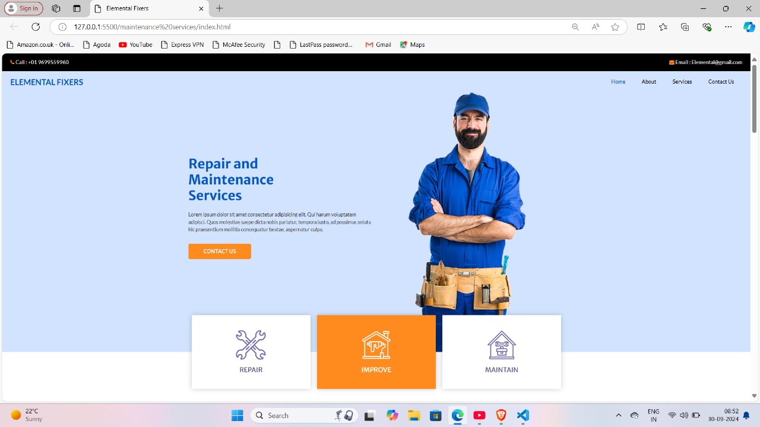

About page

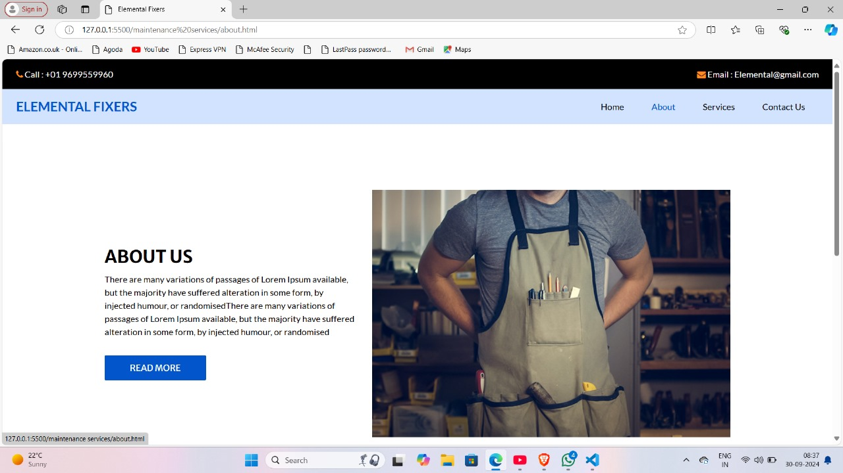

Service

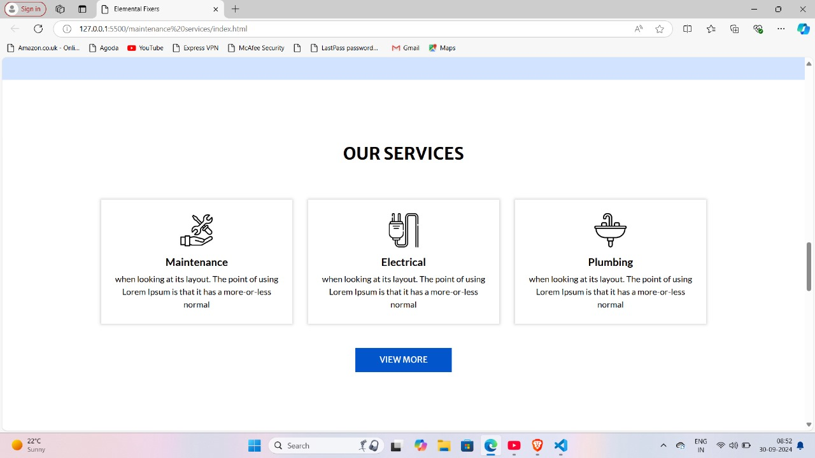

Contact

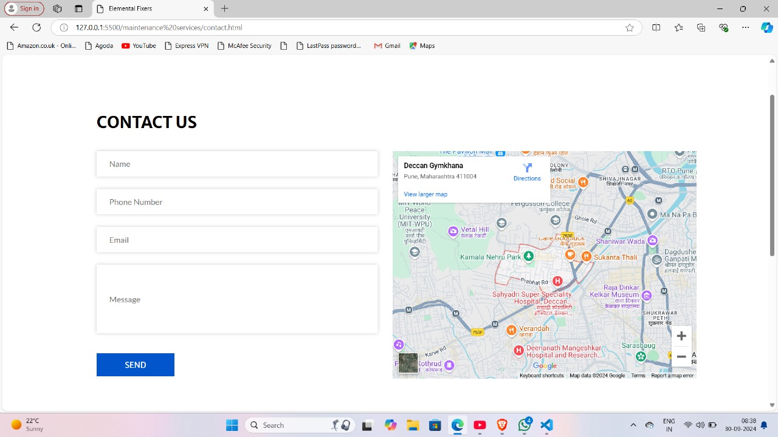

Footer

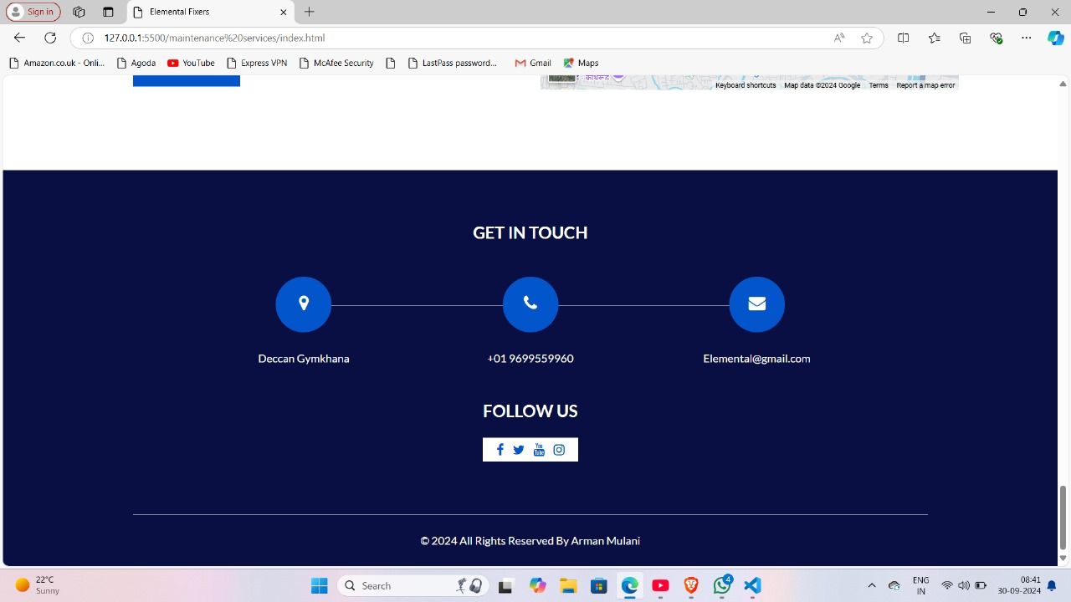

Clients

